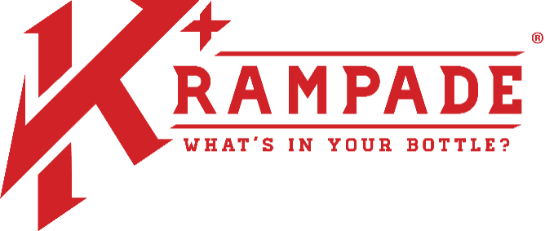
INTRODUCTION: Krampade is a family total small business that is based on the core values of using US-sourced materials, transparency, operating with overt honesty, being philanthropy driven, and applying the integrity and ethics of science to our business
Krampade, LLC
675 S. 48th St. Suite E
Grand Forks, ND 58201
701-772-3430
https://krampade.com
Capability Statement CAGE Code: 8C5Q3 DUNS#: 00-520-6226 000066006226622666226226226

Krampade is a quantum leap forward in electrolyte replacement, giving the body potassium (K⁺) that it needs. An individual needs to consume 4,700 mg of potassium daily and another 200-300 mg for each hour of exercise. However, Americans only consume ~2600 mg per day.

COMPANY DATA: NAICS: 311999 and 424490 -- All forms of payment are accepted.

DIFFERENTIATORS: Krampade is complete electrolyte replacement and is the ideal drop-in replacement for typical sports drinks.
- Prevents cramp formation while enhancing performance and recovery, while slowing fatigue via K⁺ replacement.
  - Flagship 2K line contains 2000 mg of K⁺ per serving.
  - Most sports drinks have between 30 and 70 mg of K⁺.
- High chloride content helps move water into cells improving hydration efficiency.
- Krampade 2.0 has 50 mg of bioavailable magnesium, not found in most sports drinks.
- Robust packaging meeting military specifications – store up to 200°F

CORE COMPATANCIES:
- We are the only company that produces high potassium and complete electrolyte replacement powdered sports drink.
- We strive to use the finest all-natural ingredients and packaging from the USA.
- We are an FDA registered food manufacturing facility.
  - FDA Registration #10011084506
- We are continuously innovating to deliver specialized products around our core high potassium technology, such as Krampade Fiber.
- We have comprehensive manufacturing capabilities.
  - 109,000-240,000 individual servings produced per 8 hour shift
  - Single serving sizes and bulk powders (2.5 gallon size)
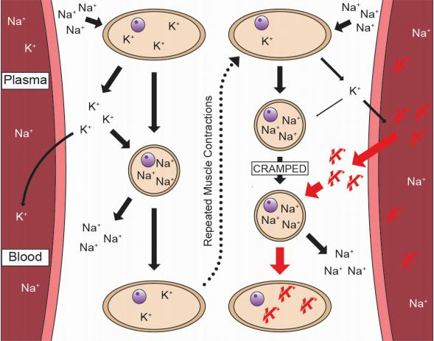
Government Business POC: Cameron C Murphy, Ph.D. Ph: (701) 213-1510, email: cameron.murphy@krampade.com
HOW KRAMPADE WORKS: FIVE KEY CONCEPTS:

1). Na⁺ goes into the muscle and K⁺ goes out, contraction occurs.

2). Most of the K⁺ goes back into the cell, but repeated contractions from vigorous or repeated contractions, reduces it.

3). When this occurs, cramping occurs.

4). Krampade shifts the equilibrium of K⁺ replacing it in the muscle, uncramping it.

5). Shifting K⁺ equilibrium via Krampade slows fatigue during moderate to intense physical activity.

Government Business POC: Cameron C Murphy, Ph.D. Ph: (701) 213-1510, email: Cameron.murphy@krampade.com

